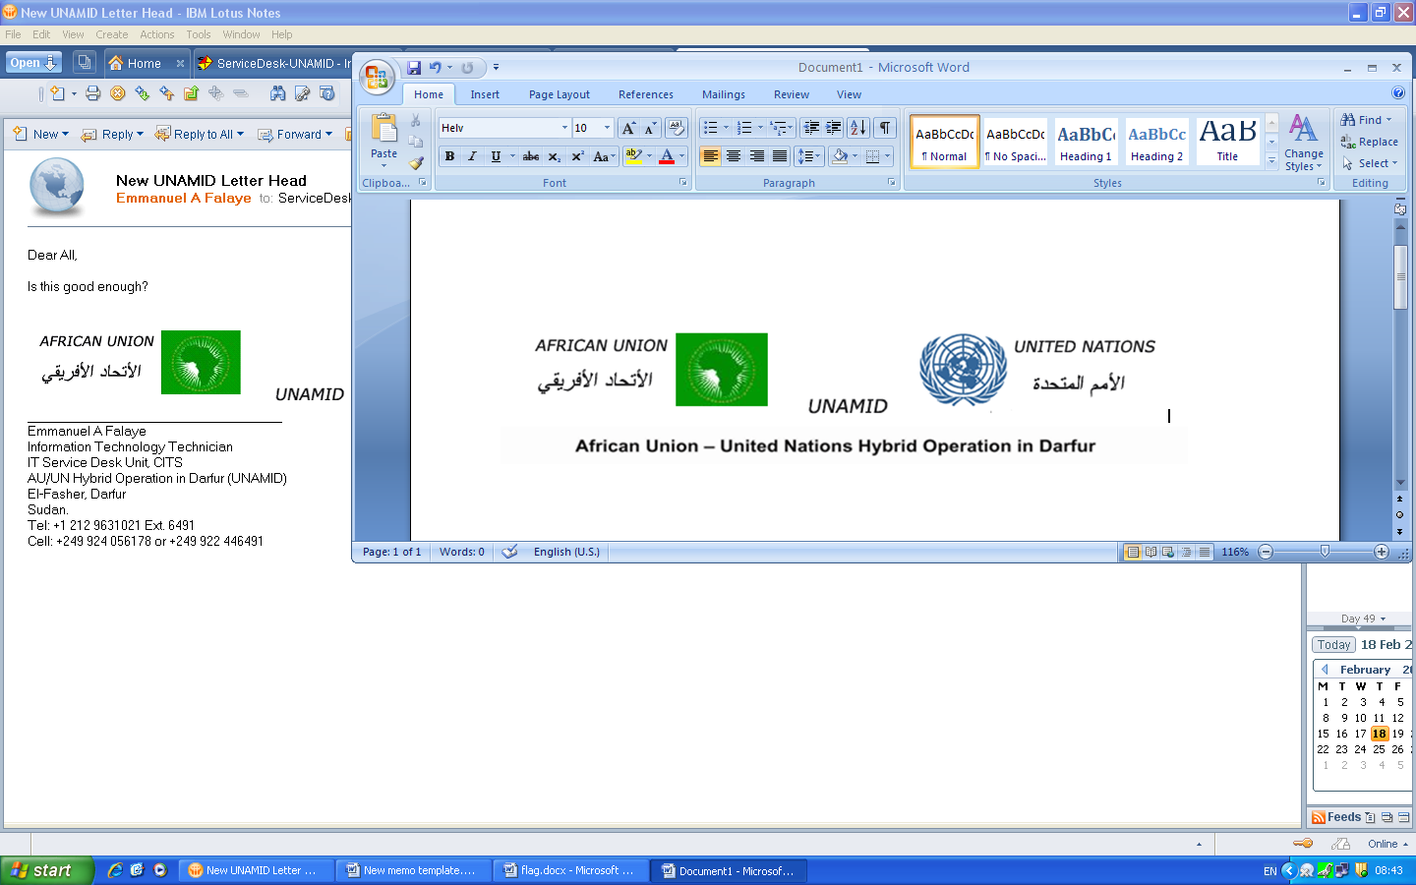

United Nations and African Union Mission in Darfur

VACANCY ANNOUNCEMENT
(Internal/External)

The United Nations and African Union Mission in Darfur (UNAMID) is seeking qualified candidates for the following position:

Before the submission of your application, please refer to the Qualifications and Experiences and Competencies sections below, and ensure that you have met the minimum requirements as mentioned.

VA No.:  UNAMID-NYL-12-008 | VA Date:  25 April 2012 | Application Deadline:  9 May 2012
Post Title:  Fire Safety Assistant | Grade:  GL-4 | Duty Stations:  Nyala

Duties and responsibilities:

Under the supervision of the Section Chief or his/her designate, the incumbent will be responsible for, but not limited to the following functions:

- Assist in a conducting fire risk assessments of UNAMID office compounds, warehouses and other general purpose areas throughout Darfur;
- Assist in recommending for suitable fire protection, early warning and fire-fighting equipment for UNAMID;
- Ensure the fire protection, early warning and fire-fighting equipment are properly installed and operational at all times;
- Conduct technical evaluation when requested by Procurement Section, of specifications of fire protection, fire-fighting and early warning equipments;
- Assist in establishment of UNAMID mission-wide fire warden system;
- Assist in conducting basic fire prevention and safety awareness training of all staff members of UNAMID throughout Darfur;
- Assist in planning and conducting fire drill;
- Assist in fighting and extinguishing fire outbreaks affecting UNAMID office compounds, assets and other general purpose areas by using the fire fighting truck, hose reels and fire extinguishers;
- Rapidly respond to fire outbreaks and other related emergencies, so as to bring them under successful control and conclusion;
- Assist in performing periodic inspection of all fire extinguishers, early warning devices and all other fire protection equipment to verify their functional status;
- Assist in translating English written fire safety broadcasts into Arabic;
- Translate English to Arabic during fire prevention and safety awareness training to Arabic speaking staff members of UNAMID.
- Assist in performing any other duties as may be assigned by the Supervisor.

Qualifications and Experience:

- Academic Backgrounds: Completion of high school education or equivalent diploma. Training in fire fighting/fire prevention/fire safety strategies from a Fire Brigade, Fire Training Academy or Fire Protection College.
- Relevant working experiences: A minimum of 4 years of progressive fire service duties within a private sector, the national civil defense, or the United Nations system experience is an asset.
- Necessary skills: Must be physically and mentally fit and willingness to work extra hours. Possess the ability to prepare and submit reports as required by the Unit. Should operate every equipment that is mounted in the fire-fighting truck;
- Languages: Excellent knowledge of spoken and written English; and fluency in Arabic. Knowledge of other languages spoken in the region applied is an asset.

Competencies:

- Professionalism: Thorough knowledge in operation of equipment installed in fire-fighting truck, fire detection devices and fire protection equipment; knowledge, skills and ability to identify fire hazards and implement measures to improve hazardous conditions; Demonstrate the ability to run hose reels from a fire fighting truck; Effectively operate the equipment responsible for discharging extinguishing agents from a fire truck; Activate and operate fire extinguishers, Familiar with Fire & Safety Unit’s operations and objectives.
- Communication: Good written and spoken communications skills; Ability to write in a clear and concise manner and to provide detailed explanations orally.
- Technological Awareness: Adequate computer skills including ability to produce fire incident/accident reports using Microsoft Word.
- Teamwork: Good interpersonal skills; Ability to work collaboratively with colleagues to achieve organizational goals; Willing to learn from others;

HOW TO APPLY
Interested and qualified applicants should submit their applications together with The United Nations Personal History form (P-11) and/or CV, a copy of own Birth Certificate, Sudanese Resident Certificate, National Passport Secondary and/or University Diploma and three references from previous employers by ONE of the following methods: (All applicants MUST indicate the VA No., Post Title and the Preferred Duty Station of which they are applying on the Subject Line (by email)/by Hand)

By Email to: unamidva-nyl@un.org
By Hand: Deliver to: UNAMID Regional Office in Nyala HQ at Super Camp.

Note: All applicants MUST indicate the VA No., Post Title and name of Duty Station of which they are applying, on the subject line [by email] or in a sealed envelope [by Mail/by Hand].) e.g. UNAMID-12-008 – Fire Safety Assistants (GL-4)

Do not submit original certificate(s) with the application. In line with the UN policy on gender balance, FEMALE CANDIDATES ARE ENCOURAGED TO APPLY.
POSITIONS OPEN FOR SUDANESE NATIONALS ONLY.

